# Steps to Cover in Current Class

* Talk about how beneficiary is Microsoft Fabric.
* Creation of Microsoft Fabric account has a catch, since we don’t have work or school account.
* Go to Microsoft Entra ID, create a user. Because the primary domain is considered as more of an organization.
* After enabling the free trail, you should start by creating a workspace.
* Name it as trial workspace.
* Once we complete the theoretical part, we can come to the demo part here.
* This is totally independent of your Microsoft fabric.
* Next topic is short cut.
* By default, data will be stored as delta lake.
* Mapping the external storage as your local storage.
* Mention in your resume about the Microsoft fabric, this would add more weightage.
* Explain the lakehouse concept and the delta format.
* Go to the workspace which you have created and create lakehouse.
* Explain the folders and tables. The unstructured and semi structured things will be in the files and the transformed content will be in the table folder.

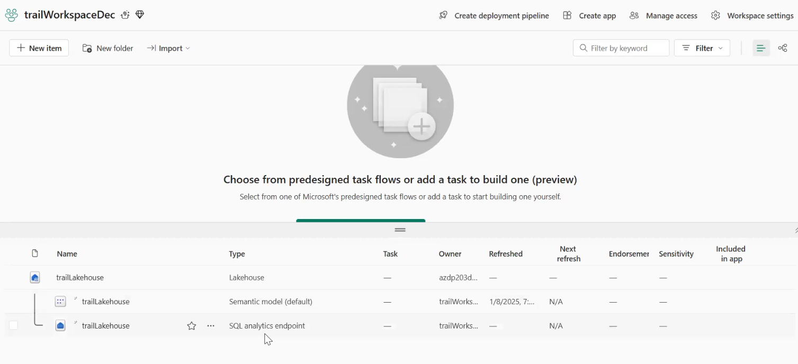

* We have two things, one type is for the adhoc analytics and the other one which is the semantic endpoint is for the visualisation or the consumption layer. These two components will always gets created.
* Go to data factory ppt, you can see the data flow is completely different from the azure data factory.
* People with the excel background it is easy to use.
* Create datafactory.
* Focus on data flow and data pipeline.
* If you click on data flow, it gives you a excel like interface. Do the transformation and store it in our excel
* Click on notebook component also. Add the lakehouse and show them.
* No click on data pipeline. Create a new one. This looks like Azure Data Factory.
* Show them the different tabs.
* Click on copy activity. Choose more to see all the connections.
* Now we can go to the warehouse section. Click to create a warehouse. The warehouse only has semantic model.
* Now we are going to talk about real time intelligence.
* Talk about KQL, kusto querying language. It is a powerful language.
* Before that create event house which is going to be our destination.
* Click on event stream. Give a name.
* Add a sample data. I have chose the yellow taxi. Event house is going to be the destination.

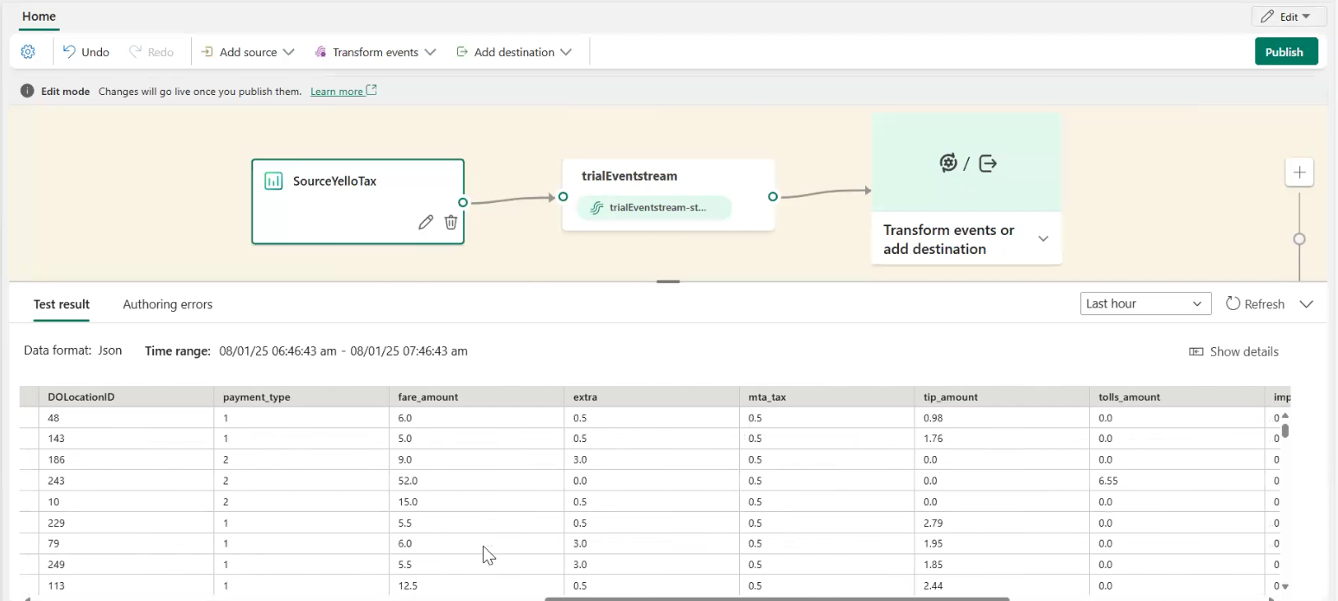

* Choose the event house.
* Choose direct ingestion. If you choose the other transformation, it basically just applies the transformation as soon the data arrives.
* By default a KQL database gets created.
* Publish it.
* You have to configure the table which you are going to run.
* Show the data insights.
* In the mean time look at the event house. About the tables which is getting created. Show them top 100 which shows in the kusto querying language.
* taxiData | Count. Run this query.
* Create queryset it will show an another window, which is used for the kusto query. They would have shown the sample queries.

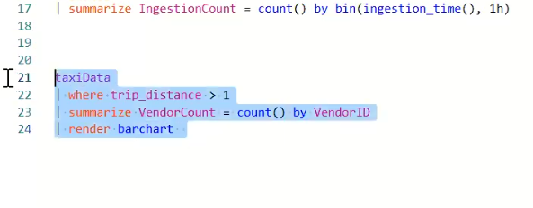

* Internall Microsoft is using this for their analysis.
* We’ll do it end to end tomorrow.
* How the cost is measured. Search for fabric capacity unit.
* Go the settings page – admin portal. Once you move from the fabric capacity it ll show in the different section.

# Intro to Microsoft Fabric

Microsoft Fabric is a comprehensive, AI-powered data platform that unifies data engineering, data science, real-time analytics, and business intelligence (BI) into a single SaaS solution. It is designed to simplify and accelerate end-to-end data management using the power of OneLake, an integrated lakehouse storage solution.

**🔷 Introduction to Microsoft Fabric**

Microsoft Fabric is an all-in-one **Data Analytics Platform as a Service (PaaS)** that integrates various Microsoft data services into a unified platform. It is built on **Azure** and combines **Azure Data Factory, Synapse Analytics, and Power BI** into a cohesive ecosystem.

**Why Microsoft Fabric?**

* **Unified Analytics Platform** – Brings together data engineering, data science, and BI.
* **OneLake Architecture** – A single, unified data lake for all workloads.
* **Lakehouse & Data Warehouse Support** – Supports both structured and unstructured data.
* **Built-in Security & Compliance** – Follows enterprise-grade security standards.
* **Optimized for AI & Machine Learning** – Deep integration with **Microsoft AI services**.

**🔷 Key Components of Microsoft Fabric**

Microsoft Fabric is built around **seven core workloads**, each catering to different analytics needs:

**1️⃣ Data Engineering**

* Provides **Spark-based** data processing.
* Supports **Apache Spark** and **Delta Lake**.
* Used for **large-scale ETL (Extract, Transform, Load) processing**.

**2️⃣ Data Science**

* Supports **machine learning (ML) model development**.
* Integrates with **Azure Machine Learning and OpenAI models**.
* Allows data scientists to **train, deploy, and manage models** within the platform.

**3️⃣ Data Factory**

* **Cloud-based ETL and ELT orchestration tool**.
* Built-in connectors for **Azure, AWS, and on-premises databases**.
* Uses **Dataflows Gen2**, an improved version of Power BI Dataflows.

**4️⃣ Data Warehousing**

* Provides a **distributed, high-performance SQL engine**.
* Uses **T-SQL for analytics**.
* Supports **Synapse SQL-based queries**.

**5️⃣ Real-Time Analytics**

* Optimized for **high-speed event streaming and real-time data ingestion**.
* Supports **Kafka, Event Hubs, IoT Hub** for real-time use cases.
* Uses **KQL (Kusto Query Language)** for fast insights.

**6️⃣ Power BI**

* Provides **self-service business intelligence (BI)**.
* Fully integrated for **dashboarding, visualization, and reporting**.
* Works directly on **OneLake without data movement**.

**7️⃣ OneLake**

* A **unified storage layer** that connects all Microsoft Fabric services.
* **Built on Delta Lake architecture**.
* Allows **multi-cloud** and **multi-format** storage access.

**🔷 Microsoft Fabric Architecture**

Microsoft Fabric follows a **lakehouse architecture** that combines the benefits of data lakes and data warehouses. It is designed with the **OneLake storage model** and supports **multiple analytics workloads** on the same data.

**Key Architectural Principles**

✅ **OneLake as the foundation** – All data is stored in a single logical lake.  
✅ **Medallion Architecture** – Bronze (raw data), Silver (cleaned data), Gold (optimized data).  
✅ **Direct Query & No Data Movement** – Power BI can query directly from OneLake.  
✅ **Tight Integration with Microsoft 365 & Azure** – Seamless experience with Excel, Teams, and Azure services.  
✅ **Security & Governance** – Built-in role-based access control (RBAC), Microsoft Purview integration.

**🔷 How Microsoft Fabric Works**

1️⃣ **Ingest Data** – Data can be ingested from various sources (Databases, APIs, IoT devices).  
2️⃣ **Transform Data** – Using **Spark, SQL, or Dataflows**, data can be processed and cleaned.  
3️⃣ **Store Data** – OneLake stores structured and unstructured data with Delta Lake.  
4️⃣ **Analyze Data** – Using SQL-based **Synapse, Power BI, or KQL queries** for insights.  
5️⃣ **AI & ML** – Data Science capabilities allow AI-powered decision-making.

**🔷 Key Advantages of Microsoft Fabric**

1️⃣ **Unified Data Lake** – No need for multiple copies of data.  
2️⃣ **Cost-Effective** – Consumption-based pricing (no need for separate services).  
3️⃣ **AI-Ready** – Fully integrated with **Azure OpenAI & Copilot**.  
4️⃣ **Simplified Data Management** – Eliminates the need for **separate data lakes, warehouses, and BI tools**.  
5️⃣ **Secure & Scalable** – Built with **enterprise-grade security** in mind.

**🔷 Comparison: Microsoft Fabric vs Other Solutions**

| **Feature** | **Microsoft Fabric** | **Databricks** | **Snowflake** | **Google BigQuery** |
| --- | --- | --- | --- | --- |
| **Storage** | OneLake (Delta Lake) | Delta Lake | Cloud Storage | Cloud Storage |
| **Compute** | Spark, SQL, KQL | Spark | Snowpark | BigQuery SQL |
| **BI Integration** | Power BI | No Native BI | No Native BI | Looker |
| **Streaming** | Yes (Real-Time Analytics) | Yes | Limited | Yes |
| **ML & AI** | Yes (Azure ML, Copilot) | Yes | Yes | Yes |
| **Security** | Microsoft Purview | Unity Catalog | Snowflake Access Control | IAM & Data Catalog |

**🔷 Use Cases of Microsoft Fabric**

1️⃣ **Supply Chain Analytics** – Real-time monitoring of inventory and logistics.  
2️⃣ **Financial Forecasting** – AI-powered insights for risk analysis.  
3️⃣ **Customer 360 & Personalization** – Unified customer data for better engagement.  
4️⃣ **IoT & Real-Time Analytics** – Edge device monitoring with low-latency streaming.  
5️⃣ **Healthcare & Compliance** – Secure patient data storage with predictive analytics.

**🔷 Hands-On Demo & Example Use Case**

**Scenario:** *Building a Data Pipeline with Microsoft Fabric*  
1️⃣ **Ingest** raw sales data from an Azure Blob Storage.  
2️⃣ **Transform** using Dataflows and Spark Notebooks.  
3️⃣ **Store** in OneLake as a Delta Table.  
4️⃣ **Analyze** using SQL Warehouse for insights.  
5️⃣ **Visualize** using Power BI dashboards.

**🔷 Challenges & Considerations**

🔸 **Learning Curve** – New users need to understand Fabric’s workloads.  
🔸 **Migration Complexity** – Moving from traditional data lakes may require effort.  
🔸 **Limited External Cloud Support** – Primarily optimized for **Azure**.  
🔸 **Performance Tuning** – Requires best practices in Spark and SQL optimization.

**🔷 Final Thoughts**

Microsoft Fabric is a **game-changer** in enterprise data analytics, offering **an integrated platform for data engineers, data scientists, and business analysts**. By leveraging **OneLake, Power BI, and Synapse**, organizations can achieve **cost savings, better governance, and AI-driven insights** in a single, seamless environment.

Would you like me to help structure this into **slides** or a **script for your talk**? 🚀